**IBM** **ASSIGNMENT** **-** **1**

|  |  |
| --- | --- |
| Team ID | PNT2022TMID50828 |
| Project Name | Smart Farming Application |

**Thinkercad** **with** **2** **sensors,** **an,Led,** **buzzer** **:**

Let's learn how to control multiple LEDs using Arduino’s digital outputs and a breadboard. Expanding upon the [last lesson on blinking an LED](https://www.instructables.com/id/Blink-an-LED-With-Arduino-in-Tinkercad/), We'll

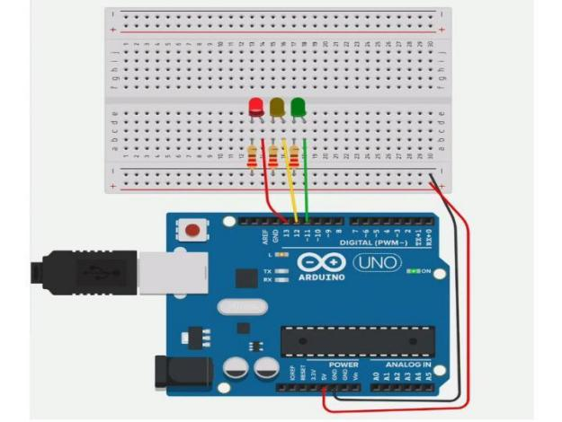

connect some LEDs to the Arduino Uno and compose a simple program to light them up in a pattern.

You can follow along virtually using [Tinkercad Circuits](https://www.tinkercad.com/circuits). You can even [view this lesson from within Tinkercad](https://www.tinkercad.com/things/newv2?tenant=circuits&lessonid=ELB4FYAJD0K8TZV&projectid=O6QUTPNJDUKI7RD&collectionid=OMOZACHJ9IR8LRE&title=Multiple%20LEDs%20&%20Breadboards) if you like! Explore the sample

circuit and build your own right next to it! Explore the sample circuit in the

workplane, and build your own along side it. Tinkercad Circuits is a free

browser-based program that lets you build and simulate circuits. It's perfect for [learning](https://www.tinkercad.com/learn/),[teaching](https://www.tinkercad.com/teach), and prototyping.

Program:

#include <ES P8266Wi Fi.h>

#include <ES P8266HTT PC lient.h>

#include <Adafruit A DS1015.h>

Wi FiC lient client;

String thingSpeakAddress= "http://api.thingspeak.com/update?";

String writeA P I Key;

String tsfie ld1Name;

String request string;

HTT PC lient http;

Adafruit A DS1115 ads;

void setup()

{

Serial.begin(115200);

de lay(3000);

Wi Fi.disconnect();

Serial.print ln("STA RT");

Wi Fi.begin("D ES KTO P","asdfghjk l"); // Wifi ("I D","Password")

while ((!(Wi Fi.status() == W L CO N N ECT E D))){

de lay(300);

Serial.print ln("...");

}

Serial.print ln("I A M CO N N ECT E D");

Serial.print ln("He llo!");

Serial.print ln("Getting sing le-ended readings from A I N0..3");

Serial.print ln("A DC Range: +/- 6.144V (1 bit = 3mV/A DS1015, 0.1875mV/A DS1115)");

ads.begin();

}

void loop()

{

int16 t adc0, adc1, adc2, adc3;

Serial.print ln(" ");

adc0 = ads.readA DC Single Ended(0);

adc0 = adc0 / 25;

adc1 = ads.readA DC Single Ended(1);

adc1 = adc1 / 25;

adc2 = ads.readA DC Single Ended(2);

adc2 = adc2 / 25;

adc3 = ads.readA DC Single Ended(3);

adc3 = adc3 / 25;

Serial.print("SO I L MO ISTU R E in persent 1% : "); Serial.print ln(adc0);

Serial.print("SO I L MO ISTU R E in persent 2% : "); Serial.print ln(adc1);

Serial.print("SO I L MO ISTU R E in persent 3% : "); Serial.print ln(adc2);

Serial.print("SO I L MO ISTU R E in persent 4% : "); Serial.print ln(adc3);

Serial.print ln(" ");

if (client.connect("api.thingspeak.com",80))

{

request string = thingSpeakAddress;

request string += "key=";

request string += "2YGO2F H N3X I3G F E7";

request string += "&";

request string += "fie ld1";

request string += "=";

request string += adc0;

http.begin(request string);

http.G ET();

http.end();

}

de lay(10);

if (client.connect("api.thingspeak.com",80))

{

request string = thingSpeakAddress;

request string += "key=";

request string += "2YGO2F H N3X I3G F E7";

request string += "&";

request string += "fie ld2";

request string += "=";

request string += adc1;

http.begin(request string);

http.G ET();

http.end();

}

de lay(10);

if (client.connect("api.thingspeak.com",80))

{

request string = thingSpeakAddress;

request string += "key=";

request string += "2YGO2F H N3X I3G F E7";

request string += "&";

request string += "fie ld3";

request string += "=";

request string += adc2;

http.begin(request string);

http.G ET();

http.end();

}

de lay(10);

if (client.connect("api.thingspeak.com",80))

{

request string = thingSpeakAddress;

request string += "key=";

request string += "2YGO2F H N3X I3G F E7";

request string += "&";

request string += "fie ld4";

request string += "=";

request string += adc3;

http.begin(request string);

http.G ET();

http.end();

}

de lay(10);}